* Purpose : Classwork
* Date : 23/12/2025
* Author : Vikas Srivastava
* ID : 55984
* Batch ID : 25SUB4505
--------------------------------------------------------------------------------------------------------------------------
- Code : Write a program to demonstrate initialization and traversal of a 2-D array, where only the first column is initialized and the remaining elements are automatically set to zero.
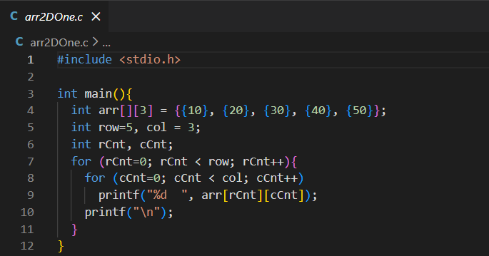
Output :
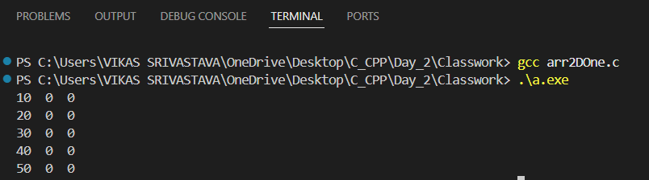

- Code : Write a program to demonstrate how a 2-D array is stored in contiguous memory and how accessing elements beyond a row using column indexing still refers to valid memory locations (row-major order), resulting in undefined but observable values.
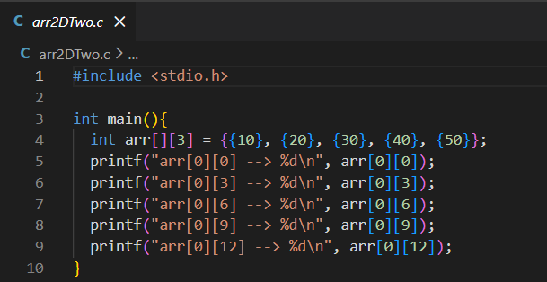
Output :
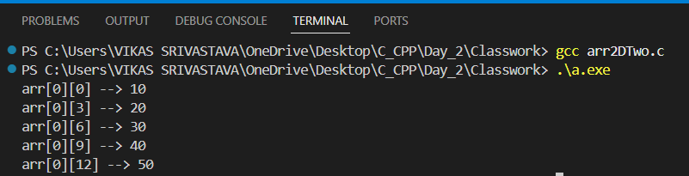

- Code : Write a program to initialize an array with 100 consecutive numbers starting from a user-given value, use a separate function to check whether a number is prime, and replace all non-prime numbers in the array with 0.
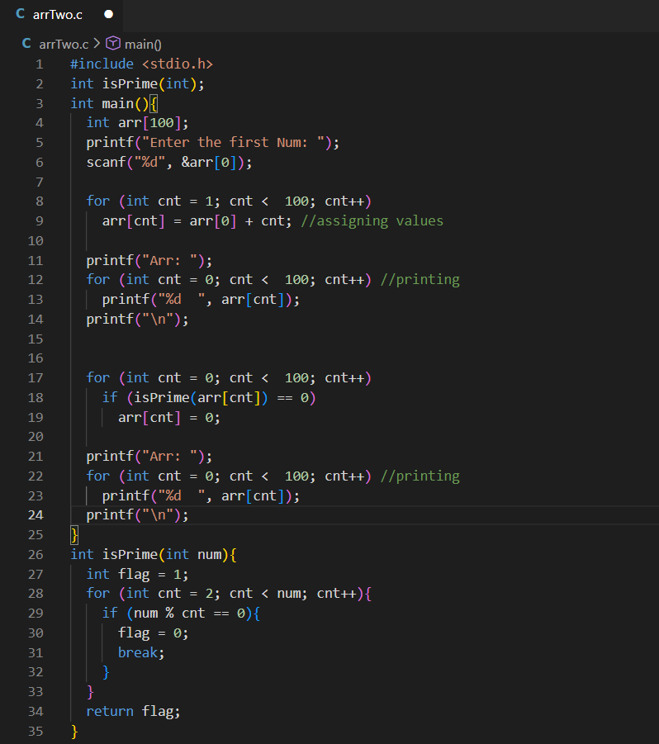

Output :
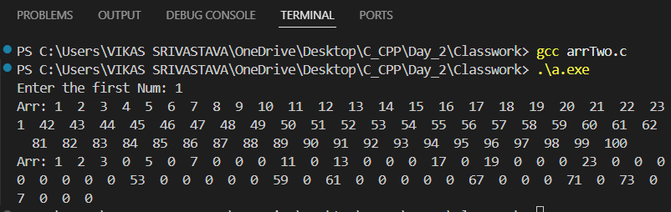

- Code : Write a program to display a formatted monthly calendar by printing the days of the week and aligning dates correctly using loops, spacing, and modulo arithmetic based on the starting weekday.
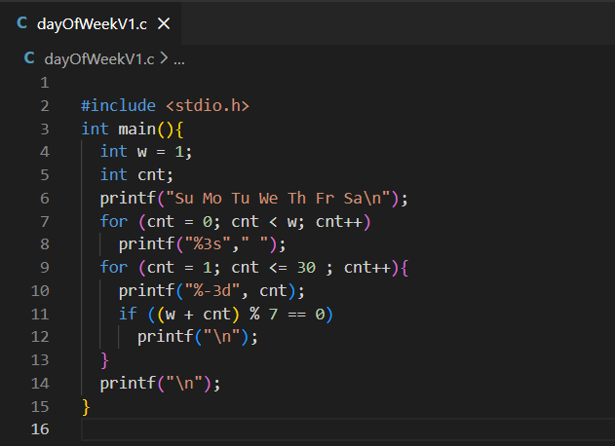

Output :
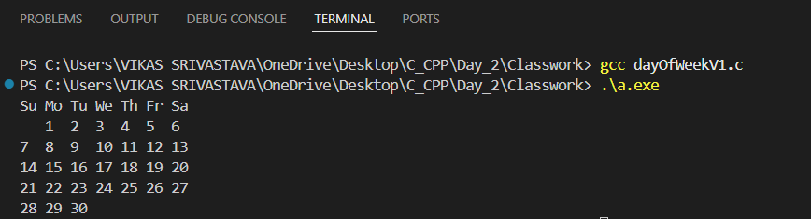

- Code : Write a program to demonstrate how multiple user-defined functions are declared, defined, and called from the main() function, showing the sequence of execution flow between main() and other functions.
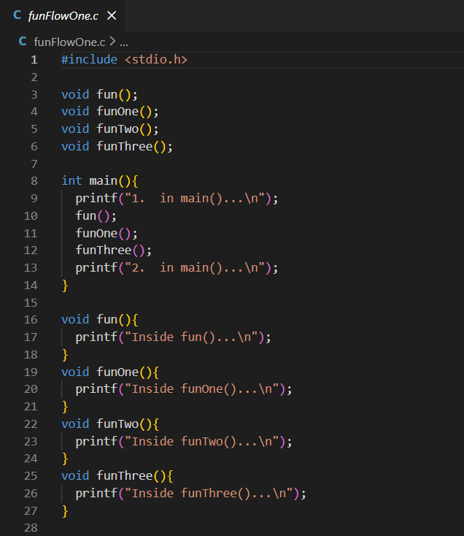

Output :
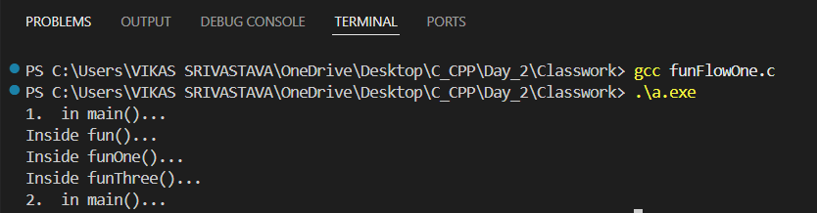

- Code : Write a program to demonstrate recursion in C, where a function repeatedly calls itself to print numbers in ascending order during the recursive calls and in descending order while returning, illustrating the call stack behaviour.
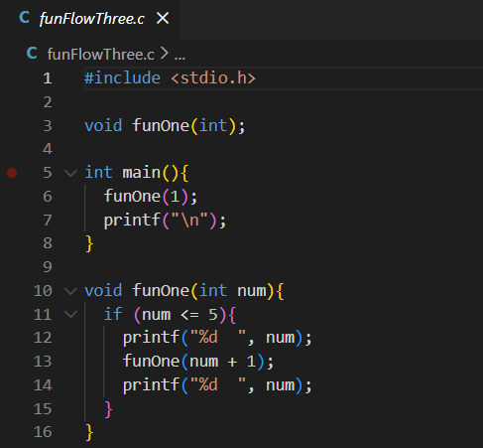

Output :
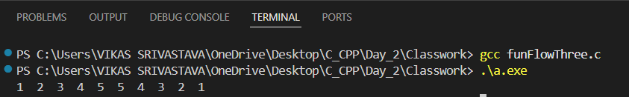

- Code : Write a program to demonstrate nested function calls in C, showing how control flows from main() to multiple functions and then returns back in Last-In–First-Out (LIFO) order.
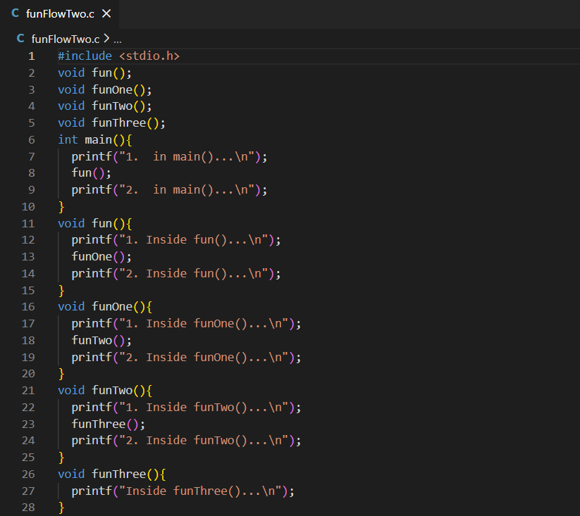

Output :
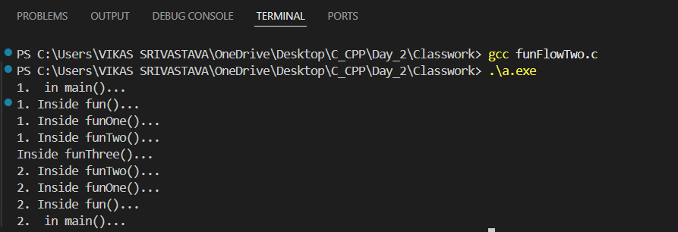

- Code : Write a program to demonstrate the use of a function prototype (declaration), followed by function definition and function call, showing how a user-defined function is invoked from the main() function.
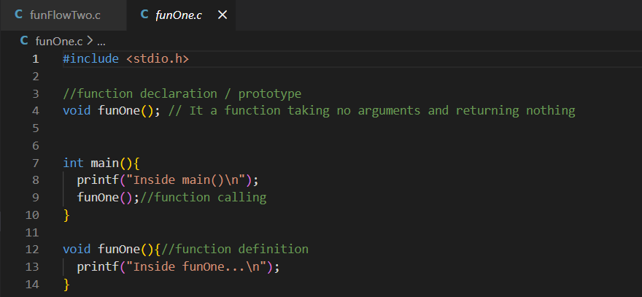

Output :
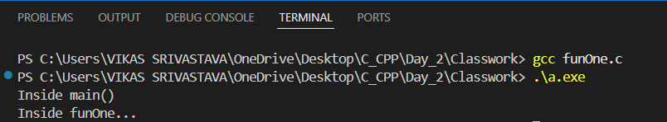

- Code : Write a program to implement a user-defined function isPrime() that checks whether a given number is prime, and demonstrate calling this function directly inside printf() to display the result.

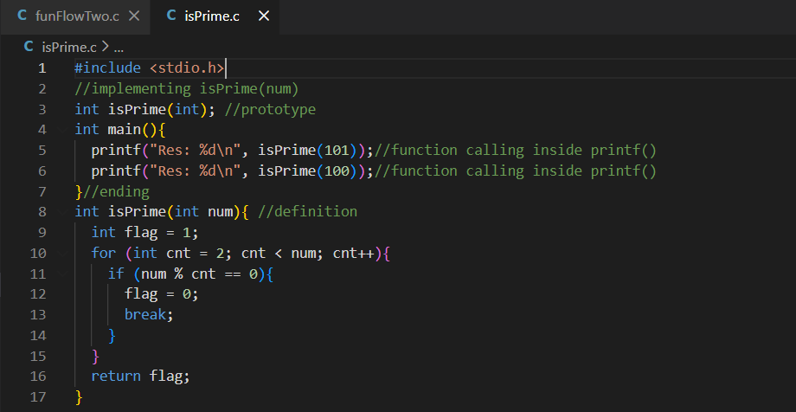
Output :
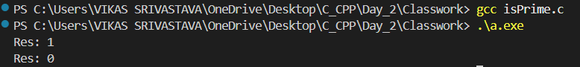

- Code : Write a program to implement a user-defined string copy function similar to strcpy(), which copies characters from a source string to a destination string until the null character is encountered, and returns the destination string.
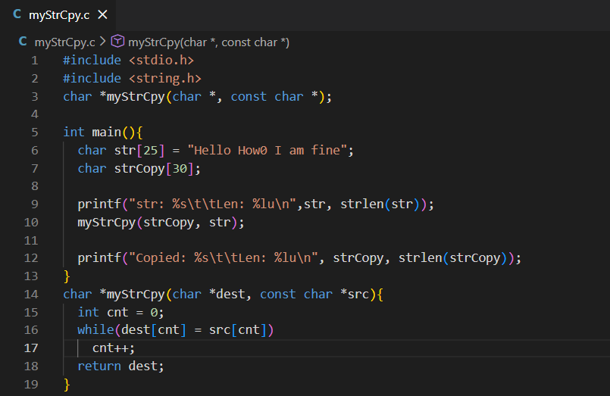

Output :
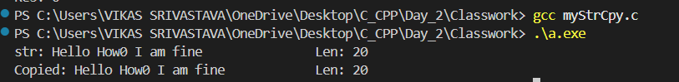

- Code : Write a program to implement a user-defined string length function similar to strlen(), which counts the number of characters in a string until the null character ('\0') is encountered and displays the string length.

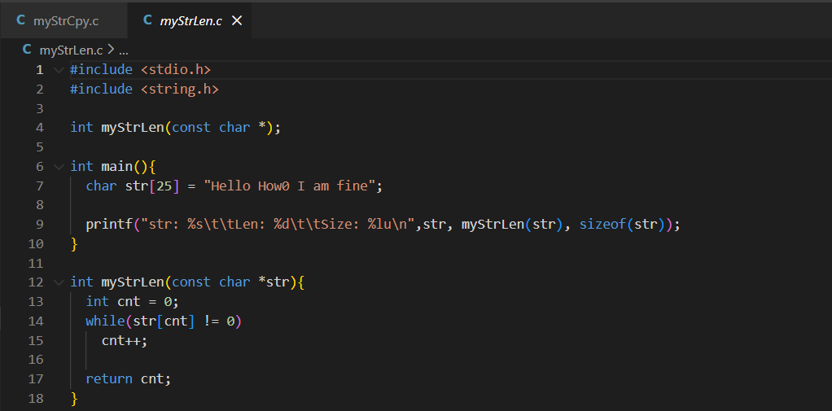

Output :

- Code : Write a program to demonstrate the use of nested for loops to print a sequential number pattern in a 5×5 matrix format, where numbers increase continuously across rows and columns.
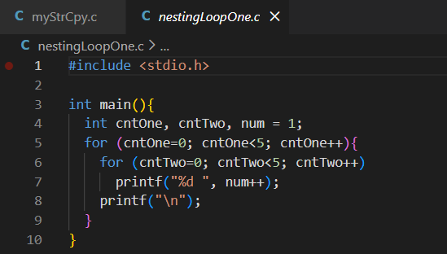

Output :
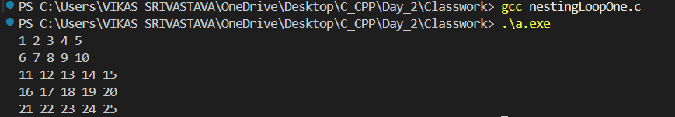

- Code : Write a program to demonstrate recursion by printing numbers from 1 to 10, where a function repeatedly calls itself until a base condition is met.

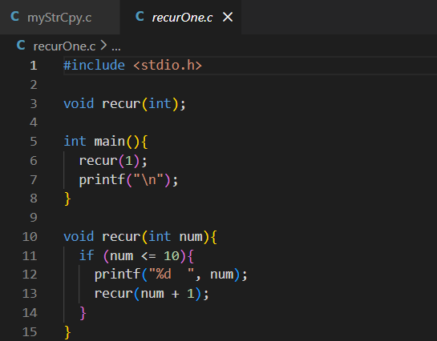

Output :
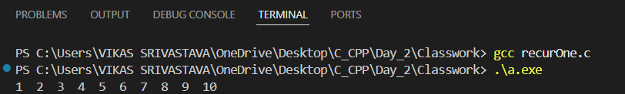

- Code : Write a program to demonstrate the use of the strcmp() function to compare two strings, showing that it returns 0 for equal strings, a negative value when the first string is lexicographically smaller, and a positive value when it is greater.
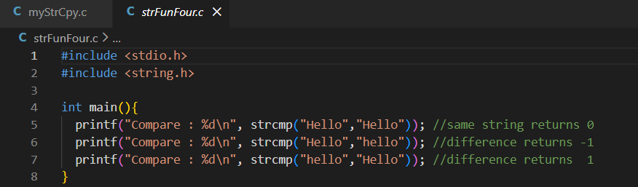

Output :
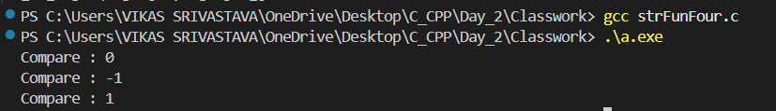

- Code : Write a program to demonstrate how a string is stored in a character array and printed on the screen using the %s format specifier in C.

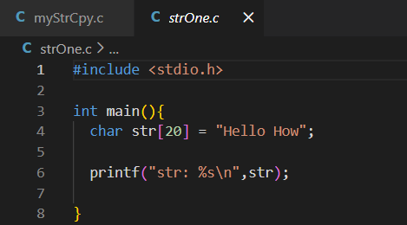

Output :

